**ASSIGNMENT (DAY 10)**

**Name: Abantika Das Modak**

**Employee ID: 46247685**

**Package: ZABN_PKG_LIT**

**Assignment 3 – Business Add in (BADI)-Single Use**

**Hint:**

1. **SE18 should be used to define a BADI**
2. **SE19 should be used to implement the BADI Definition.**

**Requirement:** Define and implement a custom BADI in SE18 to divide two numbers.

Step1: Define a BADI (ZBADI_DEMO_01…05) in SE18.

Step2: Double click on the interface created to define the methods, parameters and exceptions.

Step3: Define an instance method DIVIDE_NUMBERS.

Step4: Define two importing parameter’s (I_NUM1 & I_NUM2) and one exporting parameter (E_RESULT) of type integer

Step5: Define an exception if division is carried out using null value.

Step6: Create an implementation (ZBADI_DEMO_IMP_01...05) by specifying the BADI name that was created in step1.u

Step7: Double click on the method and write the source code to divide the two numbers.

Step8: Create a wrapper program (ZDEMO_BADI_01…05).

Step9: Define a reference variable of type BADI interface.

Step10: Define selection screen with two parameters of type integers

Step11: Call method GET_INSTANCE of the class CL_EXITHANDLER to get the BADI instance

Step12: Call method DIVIDE_NUMBERS using this instance and pass the two selection parameters.

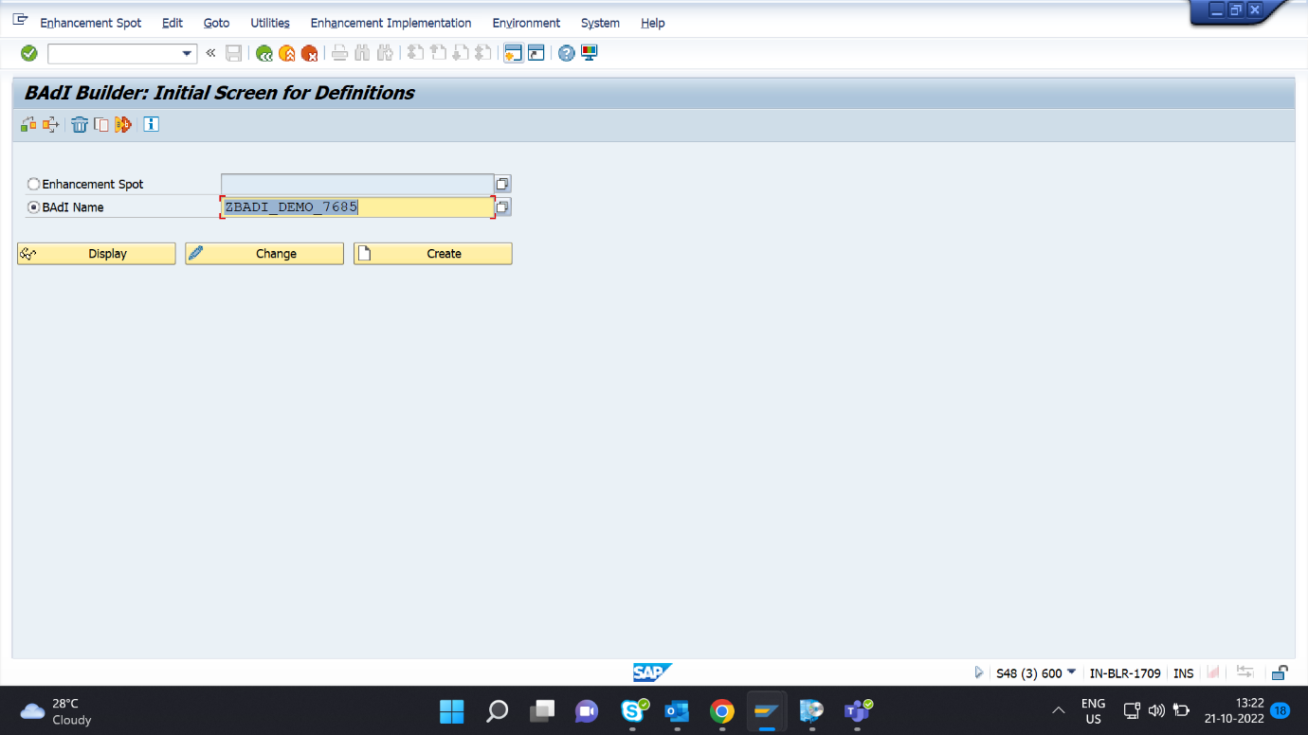

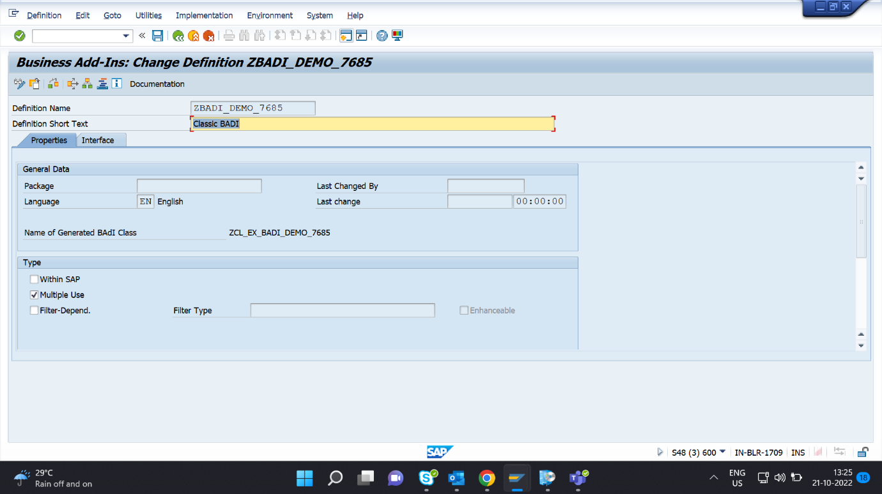

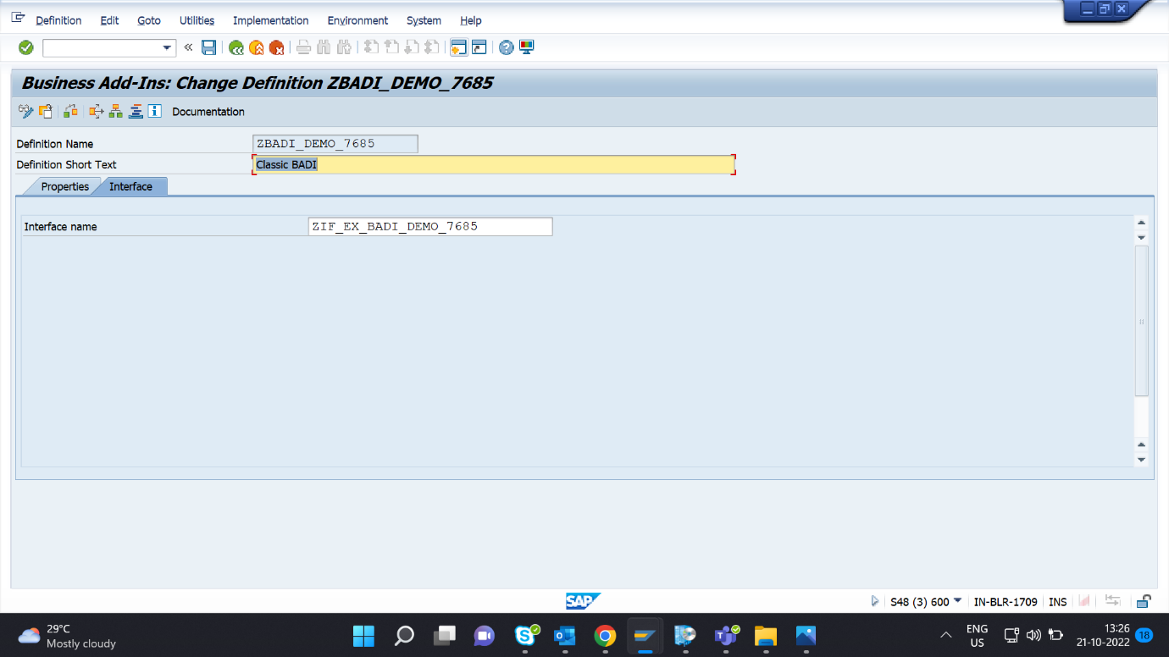

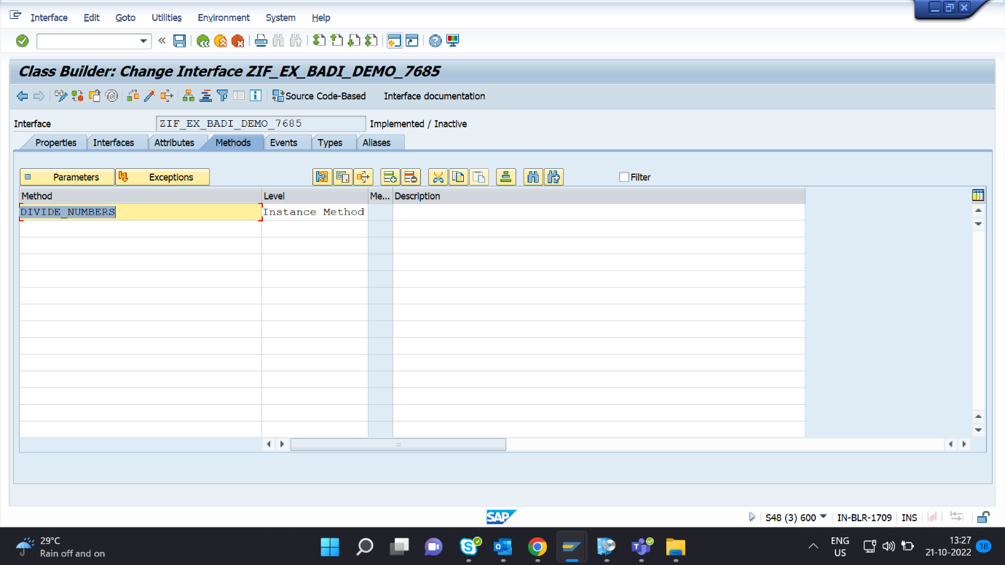

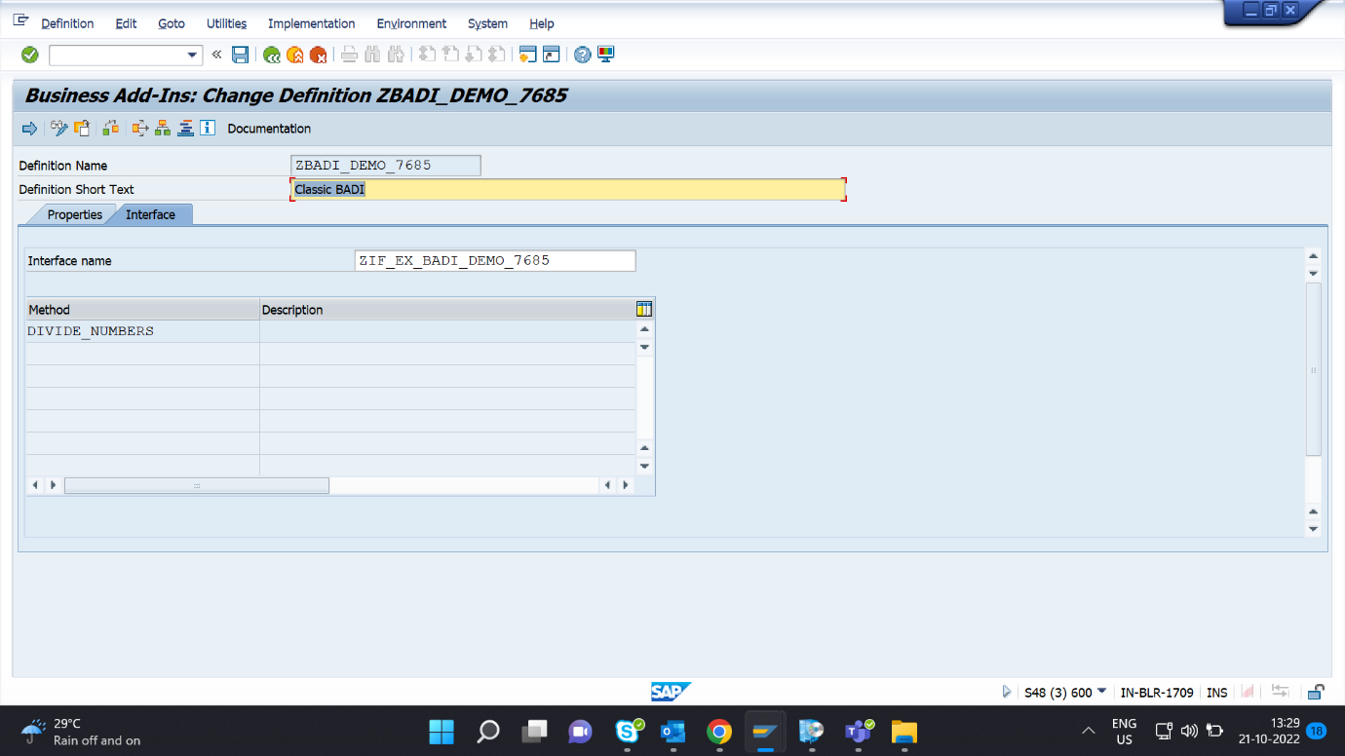

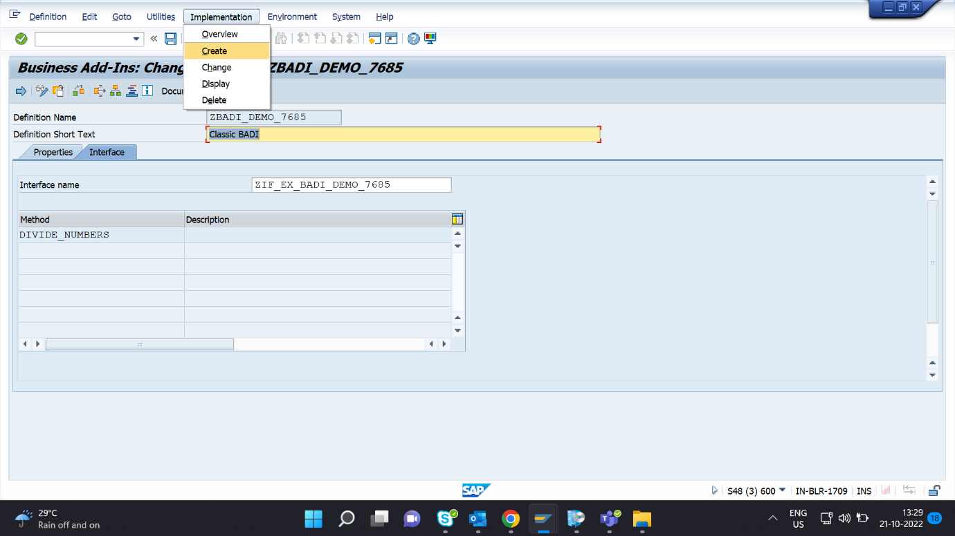

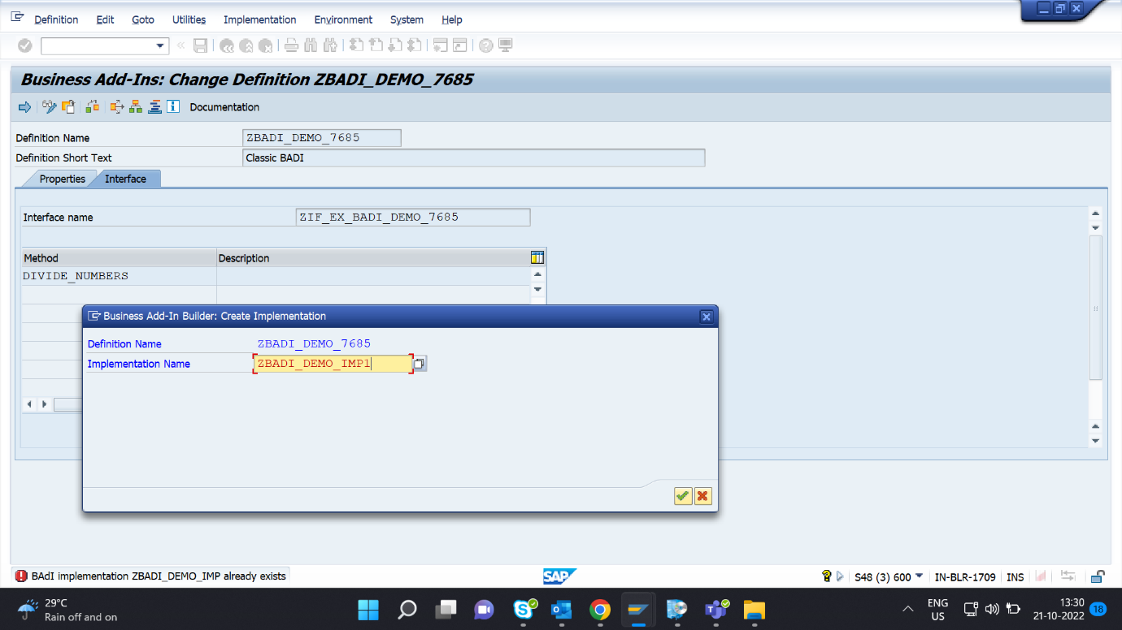

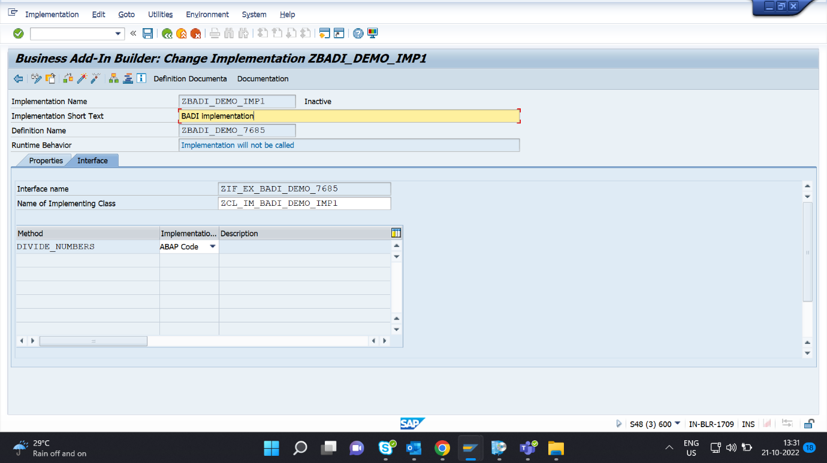

REPORT Z7685_BADI_DEMO.  
  
START-OF-SELECTION. CLASS CL_EXITHANDLER DEFINITION LOAD.  
DATA: RESULT TYPE I.  
DATA OBJ1 TYPE REF TO ZIF_EX_BADI_DEMO_7685.  
  
PARAMETERS: NUM1 TYPE I,  
            NUM2 TYPE I.  
  
CALL METHOD cl_exithandler=>get_instance  
  EXPORTING  
    exit_name                     =  'ZBADI_DEMO_7685'  
*    null_instance_accepted        = SEEX_FALSE  
*  IMPORTING  
*    act_imp_existing              =  
  CHANGING  
    instance                      = OBJ1  
  EXCEPTIONS  
    no_reference                  = 1  
    no_interface_reference        = 2  
    no_exit_interface             = 3  
    class_not_implement_interface = 4  
    single_exit_multiply_active   = 5  
    cast_error                    = 6  
    exit_not_existing             = 7  
    data_incons_in_exit_managem   = 8  
    others                        = 9  
        .  
IF sy-subrc <> 0.  
* Implement suitable error handling here  
ENDIF.  
  
TRY.  
  CALL METHOD obj1->divide_numbers  
      EXPORTING i_num1 = NUM1  
                i_num2 = NUM2 .  
 CATCH cx_sy_zerodivide .  
  
   ENDTRY.

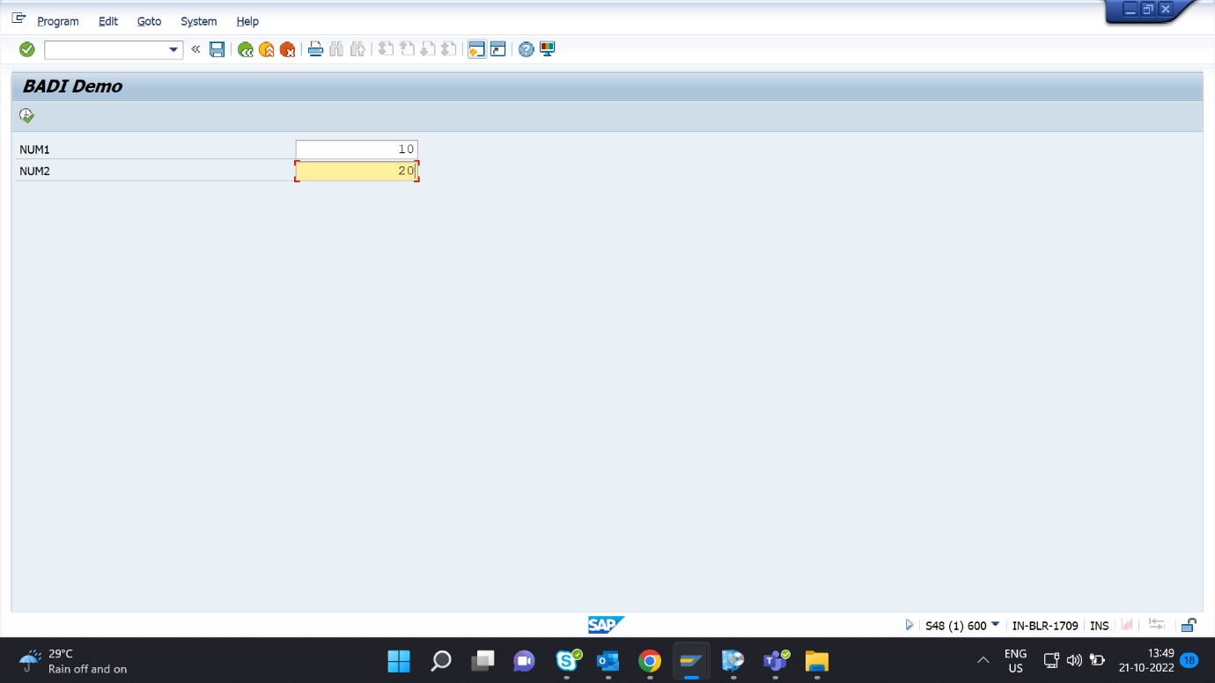

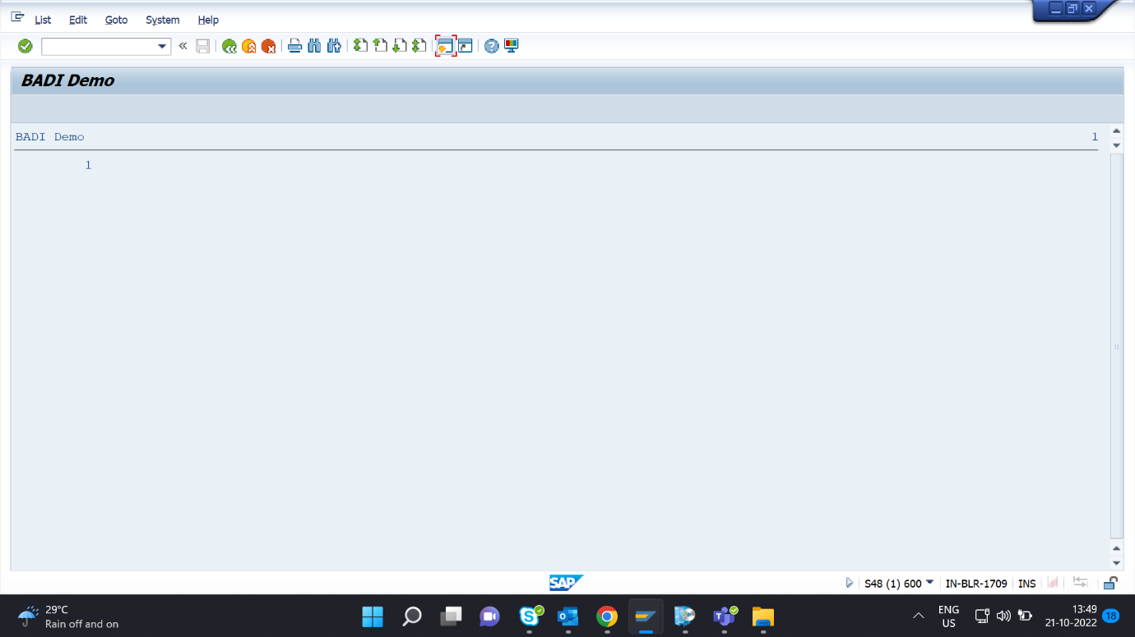

**Assignment 4 – Business Add in (BADI)-Multiple Use**

**Hint:**

1. **SE18 should be used to define a BADI**
2. **SE19 should be used to implement the BADI Definition.**

**Requirement:** Define and implement a custom BADI in SE18 to get Booking Data & Emailid.

Step1: Define a BADI (ZBADI_DEMO_01…05) in SE18.

Step2: Double click on the interface created to define the methods, parameters and exceptions.

Step3: Input Carrid & Connid Table SCARR Get, Email Data.

Step4: Input Carrid & Connid Table SBOOK Get Booking Data.

Step5: Define an exception if no data is present.

Step6: Create an implementation (ZBADI_DEMO_IMP_01...05) by specifying the BADI name that was created in step1.

Step7: Create a wrapper program (ZDEMO_BADI_01…05).

Step8: Define a reference variable of type BADI interface.

Step9: Define selection screen with two parameters of type integers

Step10: Call method GET_INSTANCE of the class CL_EXITHANDLER to get the BADI instance

Step11: Call method DIVIDE_NUMBERS using this instance and pass the two selection parameters.

Create a program to display Data of Sflight

CARRID

CONNID

FLDATE

PRICE

CURRENCY

PLANETYPE

SEATSMAX

**URL-SCARR---(From Badi)**

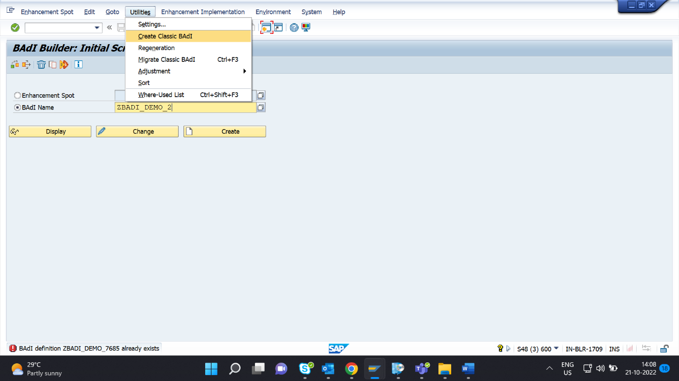

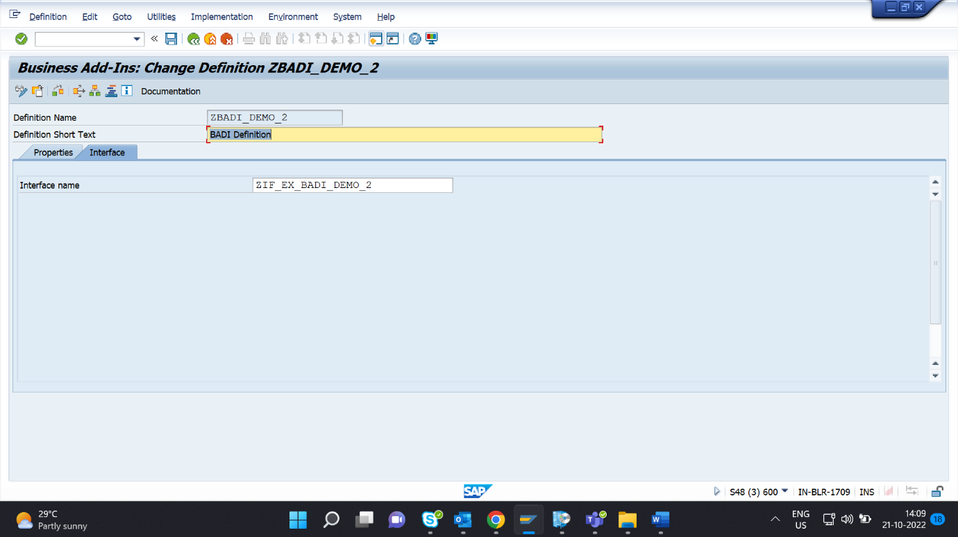

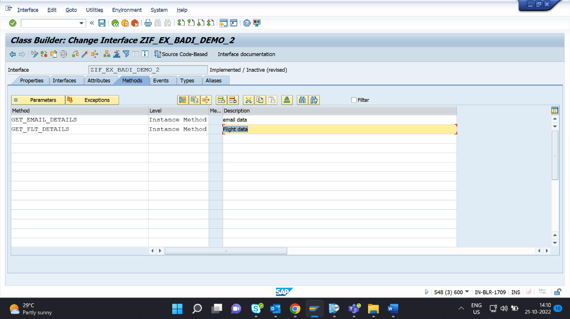

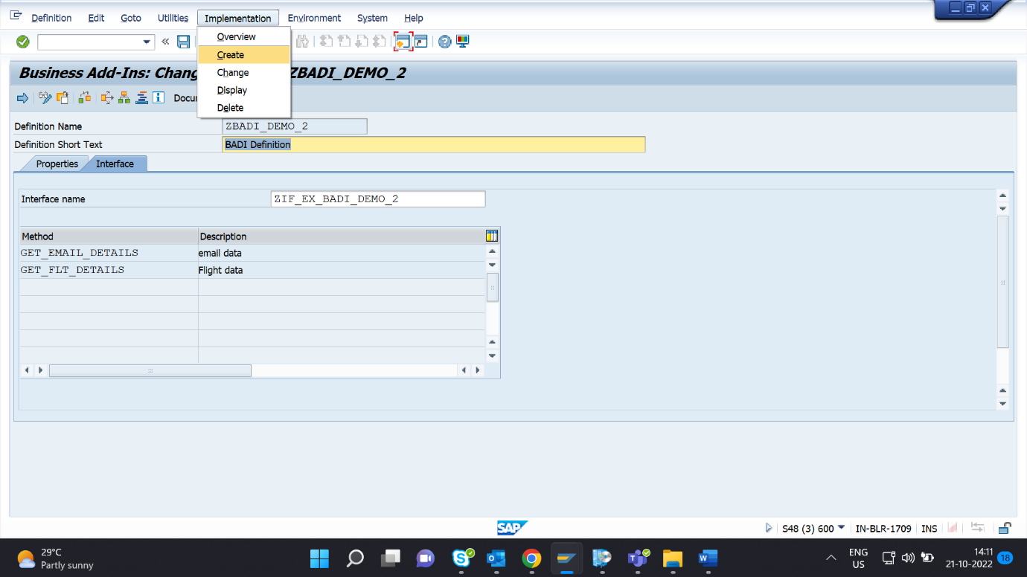

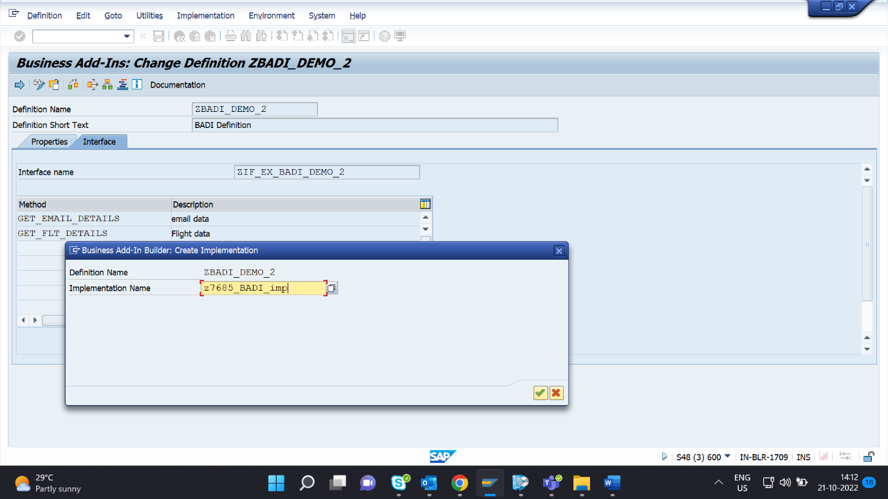

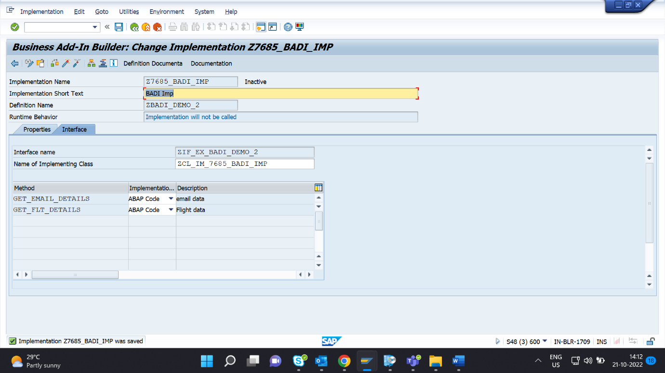

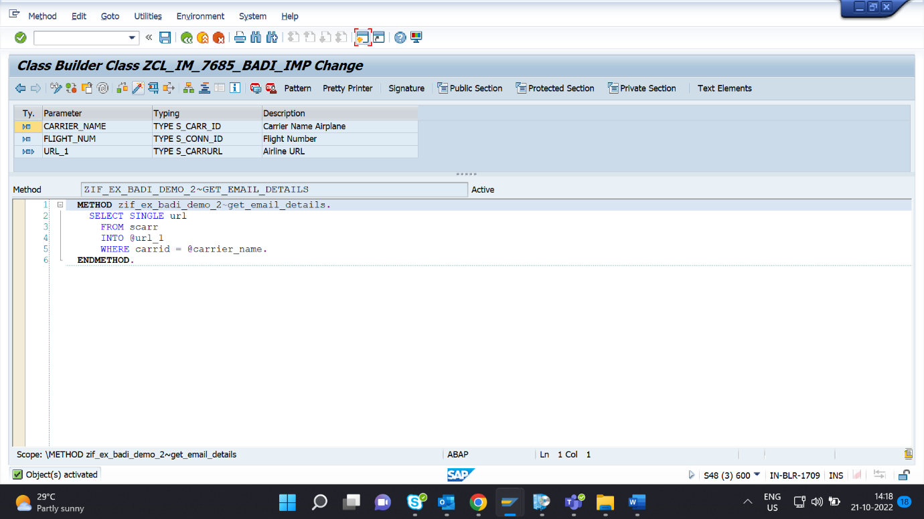

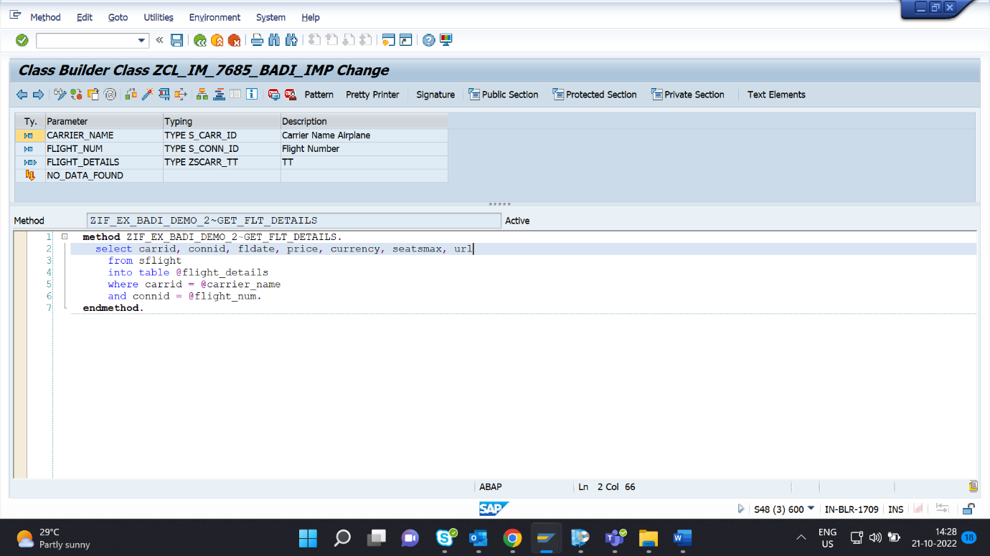

REPORT ZABN_DAY10_Q4.  
  
DATA: OBJ TYPE REF TO ZIF_EX_BADI_D10_LIT.  
  
PARAMETERS: p_carr TYPE S_CARR_ID,  
            P_flight TYPE S_CONN_ID.  
  
  
DATA : it_flight TYPE  Zscarr_tt,                          " declaring internal table of sflight  
       gs_sflight TYPE line of Zscarr_tt,  
       url type s_carrurl.  
CL_EXITHANDLER=>GET_INSTANCE(  
EXPORTING  
    EXIT_NAME                     =  'ZBADI_D10_LIT'   " Business Add-In Definition  
*    NULL_INSTANCE_ACCEPTED        =     " Is Null Instance OK if There Is no Active Implementation?  
*  IMPORTING  
*    ACT_IMP_EXISTING              =     " Returns an Active Implementation  
CHANGING  
    INSTANCE                      =  OBJ   " Instance  
EXCEPTIONS  
    NO_REFERENCE                  = 1  
    NO_INTERFACE_REFERENCE        = 2  
    NO_EXIT_INTERFACE             = 3  
    CLASS_NOT_IMPLEMENT_INTERFACE = 4  
    SINGLE_EXIT_MULTIPLY_ACTIVE   = 5  
    CAST_ERROR                    = 6  
    EXIT_NOT_EXISTING             = 7  
    DATA_INCONS_IN_EXIT_MANAGEM   = 8  
OTHERS                        = 9  
).  
IF SY-SUBRC <> 0.  
* MESSAGE ID SY-MSGID TYPE SY-MSGTY NUMBER SY-MSGNO  
*            WITH SY-MSGV1 SY-MSGV2 SY-MSGV3 SY-MSGV4.  
ENDIF.  
  
CALL METHOD obj->get_flt_details  
  EXPORTING  
    carrier_name   = p_carr  
    flight_num     = p_flight  
  CHANGING  
    flight_details = it_flight  
*  EXCEPTIONS  
*    no_data_found  = 1  
*    others         = 2  
        .  
IF sy-subrc <> 0.  
* Implement suitable error handling here  
ENDIF.  
  
  
  
  
  
CALL METHOD obj->get_email_details  
  EXPORTING  
    carrier_name = p_carr  
    flight_num   = p_flight  
  CHANGING  
    url          = url  
    .  
  
  
  
WRITE: / 'Airline URL is' COLOR COL_POSITIVE,  url.  
WRITE: 40 'Flight Details' COLOR COL_POSITIVE.  
WRITE: / 'CARRID',  
10 'CONNID',  
20 'FLDATE',  
31 '      PRICE',  
52 'CURRENCY',  
63 'PLANETYPE',  
75 'SEATSMAX'.  
ULINE.  
LOOP AT it_flight INTO gs_sflight.  
WRITE : /  gs_sflight-carrid LEFT-JUSTIFIED,  
10 gs_sflight-connid,  
20 gs_sflight-fldate,  
31 gs_sflight-price,  
52 gs_sflight-currency,  
63 gs_sflight-planetype,  
75 gs_sflight-seatsmax.  
ENDLOOP.

